PSP0201
Week 4 Writeup

Group name: SOLO
ID | NAME | ROLE
1211100574 | Ivan Liew Qi Hong | leader

Day 11: [Networking] The Rouge Gnome: Prelude
Tools used: Kali Linux, Firefox
Solution/Walkthrough:
Question 1
Answer is vertical because commands can be executed by a higher privileged account

Question 2
Answer is vertical because commands can be executed by a higher privileged account

Question 3
Answer is horizontal because commands can be executed by a equally privileged account

Question 4
Answer found in text

Question 5
Answer found in text

Question 6
Answer found in text

Question 7
Answer found in text

Question 8
User ssh command to login
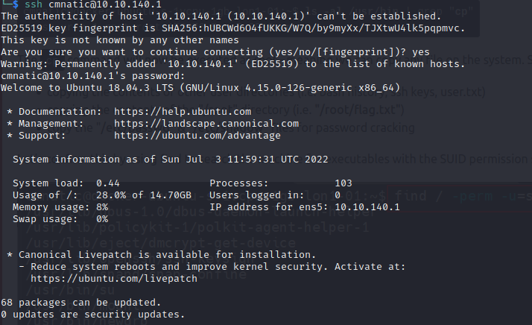
Use bash command to become root and locate flag.txt
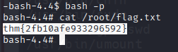

Thought Process/Methodology:
I got most of the answer from reading the text and searching it up. To get the flag I entered the ssh command and the password given to login. I then used a bash command to gain access to the root which I then used to get the flag.

Day 12: [Networking] Ready, Set, Elf.
Tools used: Kali Linux, Firefox
Solution/Walkthrough:
Question 1
Use nmap command with ip address to find version number

Question 2
Search for Apache 9.0.17 metasploit and click on exploit.db link to find CVE
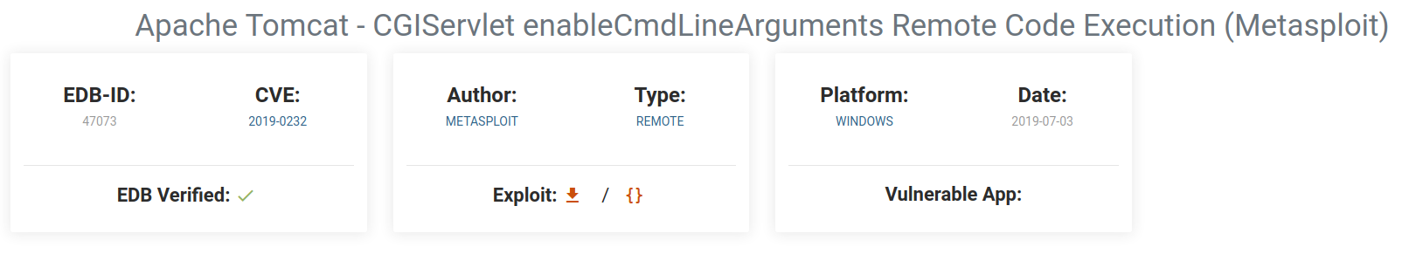

Question 3
Use command msfconsole and configure LHOST and RHOST. Use script given to gain access and locate flag1.txt

Question 4
Answer in text

Thought Process/Methodology:
I found the web version number by using the nmap command. I then searched said version number to find it’s CVE. After that I then used the command msfconsole and configured the LHOST and RHOST before using the script given to gain access to elfmcskidy’s directories to obtain the flag.

Day 13: [Networking] Coal For Christmas
Tools used: Kali Linux, Firefox
Solution/Walkthrough:
Question 1
Use nmap to check protocol and services to find old and deprecated one
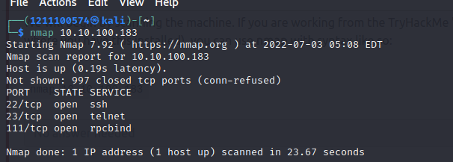

Question 2
Enter the command telnet with the ip address and port to get the credentials
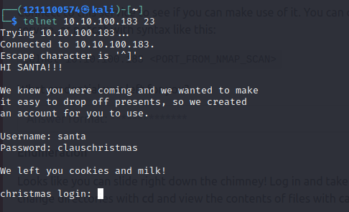

Question 3
Using command cat /etc/*release to find distribution of Linux and version number
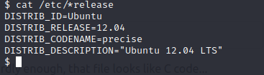

Question 4
Use cat cookies_and_milk.txt to find who got there first
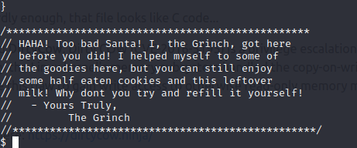

Question 5
Copy a string of code and search for it on the internet. Then look at the compile comment in the code
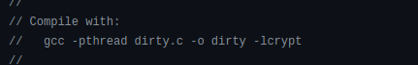

Question 6
Copy and paste dirty cow code into text file into the directory then compile it
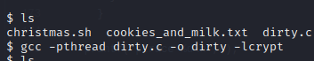
Use ./dirty and enter new password and login to find new username
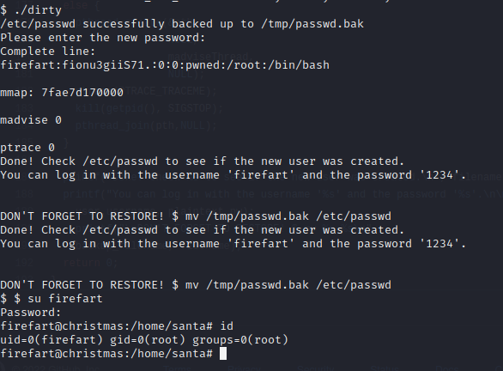

Question 7
Go to root directory and search for grinch’s message
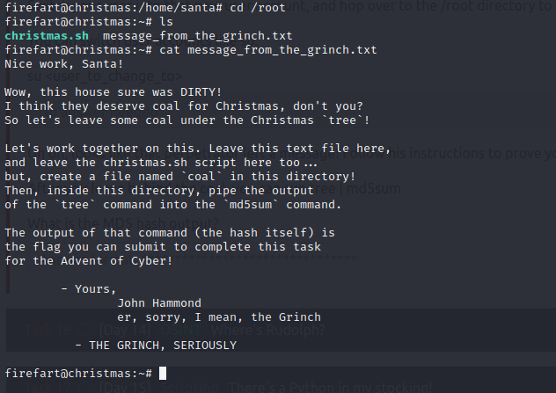
Add coal text file and pipe tree in md5sum to get hash
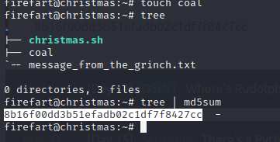

Question 8
The CVE can be found by searching the internet

Thought Process/Methodology:
I used the nmap command to find the old protocol and service. I then used the telnet command to find the credentials that had been left behind. I Then used the command cat /etc/*release to find the distribution information and looked at the cookies and milk text file to see who was here first. I then copy a string of code to locate which dirtycow code was used and copied it into a separate text file which I then compiled and used. I then changed to user to firefart and entered the root directory to read the text file left by the grinch. Following his instructions I added a coal text file and piped the output of tree and md5sum to get the hash.

Day 14: [OSINT] Where’s Rudolph
Tools used: Kali Linux, Firefox
Solution/Walkthrough:
Question 1
Go to Rudolph’s reddit account and go to the comments tab

Question 2
Answer is in the comments

Question 3
Google the answer

Question 4
Answer is stated in a comment made by Rudolph

Question 5
Search for iguidetheclaus2020 in twitter to find Rudolph’s twitter username

Question 6
Answer is bachelorette found in his twitter

Question 7
Answer is Chicago which can be found by saving the photo of Rudolph at the parade and searching it

Question 8
Save picture and use Exif viewer to find coordinates

Question 9
Flag is under copyright section

Question 10

Question 11
Google the Magnificent Mile in Marriot to find street number

Thought Process/Methodology:
I went to Rudolph’s reddit account and entered his comments tab to get the url. I then looked through the comments to find out where he was born and googled his creator’s last name. I then searched for his twitter username by using his reddit’s username and found out his favourite TV show by looking at his posts and searched a picture of him at the parade to locate where it was held. I then saved the higher resolution photo and used an Exif viewer to see the coordinates as well as the flag. I then googled where he stayed to get his street number.

Day 15: [Scripting] There’s a Python In My Stocking!
Tools used: Kali Linux, Firefox
Solution/Walkthrough:
Question 1
The answer is 2 because we are adding 2 like inputs

Question 2
Answer can be found be searching the internet

Question 3
Answer is True because it’s a string

Question 4
Answer can be found in the text

Question 5
Run the code to get the answer

Question 6
Answer can be found in text

Question 7
The answer is the wise one has allowed you to come in because the name is as saved in the name list

Question 8
The answer is the wise has not allowed you to come in because the name has a lowercase.

Thought Process/Methodology:
I found most of the answers by reading the tasks and searching of the internet. I also ran a python code to find the outputs as well.

